Thomas Duncan Moodie – A Study in Perseverance

From a very early age, Thomas Duncan Moodie had a dream. Born in 1908, Tom, as he was affectionately called, dreamt of becoming a minister in the Dutch Reformed Church. As a young boy of eight years old, he would scramble onto an anthill on his father’s farm in Heidelberg, a district of the former Transvaal province in South Africa, and deliver sermons to his playmates, the farm workers' children. He visualised himself ascending a real pulpit one day.

But at the end of his first year of high school, Tom's dream was crushed. His father, a Justice of the Peace, deemed that he was sufficiently educated, and he was ordered to abandon his studies and to go and work on the farm.

Perhaps Tom knew it, perhaps not, but the road to becoming a Dutch Reformed minister was a long and challenging one: first, one had to complete high school, i.e. pass Standard 10 with university admission. This was followed by a three-year bachelor’s degree, culminating with four years at the Theological Seminary in Stellenbosch, the idyllic university town east of Cape Town.

When his father aborted his studies, Tom had only passed Standard 6, or Grade 8 as it is now known. He was still four years short of achieving just the first step toward realising his dream.

Then, in 1933, Tom's dream all but vanished when, in the midst of the Great Depression, the family lost their farm. Like many other young Afrikaans men, Tom had to pack his bags and head for the big city to try and earn a living. He found a job with Nourse Mines, a gold mine in the eastern suburbs of Johannesburg, where he worked the nightshift underground. This was hard, exhausting, often dangerous, work, carried out in semi-darkness in an unhealthy environment.

At this point, most people would have given up on their dream. But the blood of the Moodies, who tamed the inhospitable Orkneys, sailed the roughest of seas, and opened up new territories, flowed strongly through Tom's veins.

He had never abandoned his dream, and he was determined to see it through. So he set his sights on overcoming the first obstacle: he had to obtain his high school diploma with university admission. Because he had to work fulltime, he chose to enrol at a correspondence college.

Every evening Tom would descend into the bowels of the earth to do his shift as a miner. And every day, after only a few hours of sleep, he could be found bent over one of his textbooks, furiously studying.

After four years of dedication, Tom held the coveted certificate in his hands. The door was finally open, and he was admitted to the University of Pretoria.

But by now Tom had a wife and child to support, so he embarked on what many people would regard as humanly impossible: every morning he would catch the train to Pretoria, some 62 km (39 miles) from Johannesburg, attend lectures full-time, return in the afternoon, catch a couple of hours sleep, and then descend down the mineshaft to work a full nightshift.

Tom kept this up for a year until his wife stepped in. She decided to find a job so that he could stop working as a miner and concentrate on his studies. She started working in a bookshop and, after having worked for 10 years as and underground miner, Tom moved to Pretoria. Four years later, he graduated and the door was open for him to enroll at the Theological Seminary in Stellenbosch.

The family was apart for that first year while Tom lodged in a private hostel. He later found a house to rent and the following year his wife and two children – a boy and a girl – joined him.

In 1951, at the age of 43, Tom's dream finally came true when he was admitted as a minister in the Dutch Reformed Church. His first call was to the Petrus Steyn congregation in the Orange Free State. On the day he was ordained and ascended the pulpit for the first time, he stated that his goal was to serve as a minister for 25 years.

In 1958, he left Petrus Steyn to become a minister at the Brenthurst congregation in Brakpan, a mining town in the old Transvaal. On 6 November 1960 his wife, who supported him during all those years and helped him to realise his dream, died from a stroke while playing the organ during the evening service. Tom remarried a year later.

One day, in May 1964, on his way back from Malawi, Tom stopped in Chipinga (now Chipinge), in what is now Zimbabwe, at the grave and monument erected in honour of his grandfather, Groot Tom Moodie, the leader of the first trek to Rhodesia. A farmer started chatting to him and Tom mentioned that he was a minister in the Dutch Reformed Church, and a grandson of Groot Tom.

Soon after, he received a call from the Melsetter congregation. He accepted and, in June 1964, he became a minister in the same village his grandfather founded 70 years earlier.

Tom's last congregation was Bloemhof in the Western Transvaal, where he ministered for 10 years. In 1976, he contracted bladder cancer and was hospitalised. He recovered enough to return to the congregation, where he held his farewell sermon on 18 June 1977, four months after achieving his goal of serving for 25 years. He retired to the town of Kempton Park, and died six months later.

This is Tom, about a year after he started working as an underground miner:

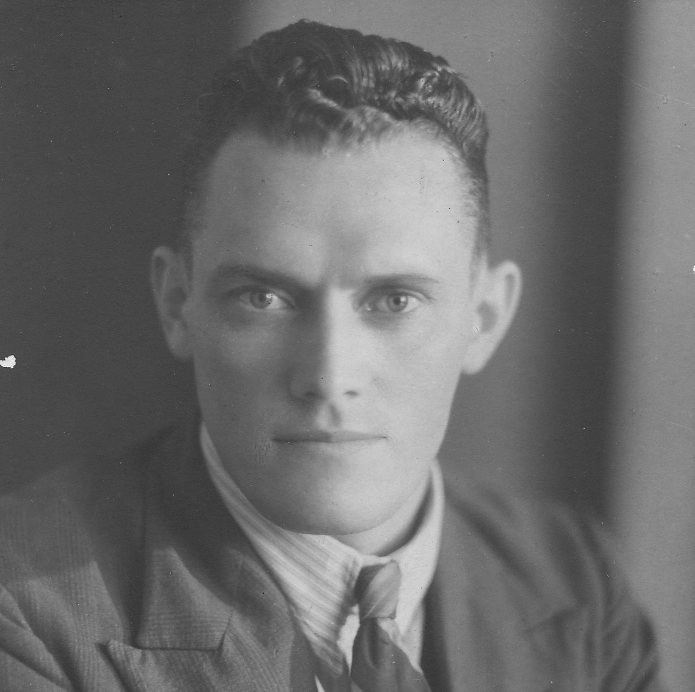

And here is Tom on the day he was admitted as a minister in the Dutch Reformed church:

